**RAAYAT ISLAMIC NUR & PRIMARY SCHOOL**

**MID-TERM ONE EXAMINATION, 2024**

**LITERACY 1 B – P.1**

**TIME: 2HRS 15 MINS2023**

CLASS P.1 ENGLISH JUNIOR SCHOOL

AND DAYCARE CENTRE

MID TERM ONE EXAMINATION 2023

CLASS P.1 ENGLISH

**Name: ____________________________________________**

**1. A _________________________ is a place where we go to learn.**

**2. Name two things found in class.**

**i)______________________________ii)_______________________________**

**3. Draw a teacher.**

**4. Who heads a school? _______________________________________**

**(matron , head teacher)**

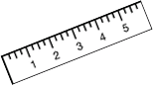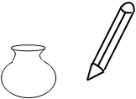**5. Fill in the missing letters.**

**p ___nci___ ru___er ch ___ ___r**

**6. A ____________________ cooks food at school.**

**7. Why do we go to school?**

**________________________________________________________________**

**( To cook , To learn)**

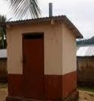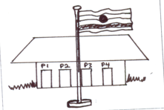**8. Name these building.**

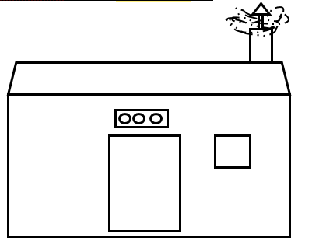 **___________________ ___________________**

**___________________**

**(classrooms , kitchen , toilet)**

**9. Tick ways of cleaning the school.**

**By mopping By cooking By digging By sweeping**

**10. Write two people found at school.**

**i)______________________________ii)_______________________________**

**11. Name three people found at home.**

**i)______________________________ii)______________________________**

**iii)_____________________________**

**(plant , mother , doll , father , sister)**

**12. Draw,**

|  |  |  |
| --- | --- | --- |
| **broom** | **rake** | **rag** |
|  |  |  |

**13. Where are school books kept?**

**______________________________________________________________**

**14. My class teacher is teacher ______________________________.**

**(Mutajaz , Asia)**

**15. Match correctly.**

**Mr. Hadijjah**

**Madam Mutajazi**

**Teacher Nassuna**

**16. The school ___________________ drives the van.**

**(bursar , driver)**

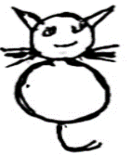**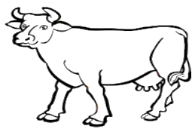17. Name the following animals.**

**___________________ ___________________**

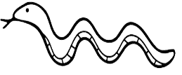

**____________________**

**18. Who heads a family? _____________________________________**

**(doctor , father)**

**19. How do you come to school? ______________________________**

**(By car, On foot)**

**20. Name these important places.**

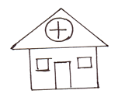**_________________ ________________**

**(onion , school , hospital)**

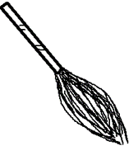**21. Match**

**bucket**

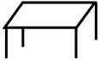

 **cup**

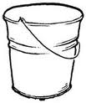 **broom**

**table**

**22. Draw**

**grandfather father brother**

**23. Complete correctly.**

**A teacher uses __________________________________**

**A cleaner uses a _________________________________**

**A school uses a __________________________________**

**24. Name three things found at home.**

**____________________ __________________ ________________**

**( aeroplane , knife , plate , cup)**